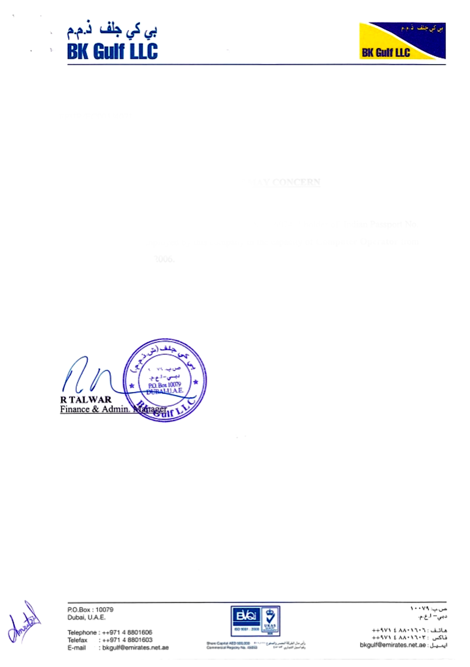

EPHR/ECOO1/4071

<To>

**TO WHOM IT MAY CONCERN**

We certify that Mr. <Name> holder of Pakistani Passport No.   
<Passport> had been employed by this company in the capacity of <Designation> from <From> to <To>.

For BK Gulf LLC

This is the only offical, record of service issued by the company, should further detail be requried pleae contact the signatory